**Week - 8**

**(10 August 2023)**

**Experiment - 8**

**Question:**

Write a C program to simulate paging technique of memory management.

**Program:**

#include<stdio.h>

#define MAX 50

int main()

{

int page[MAX],i,n,f,ps,off,pno;

int choice=0;

printf("Enter the number of pages in memory: ");

scanf("%d",&n);

printf("\nEnter Page size: ");

scanf("%d",&ps);

printf("\nEnter number of frames: ");

scanf("%d",&f);

for(i=0;i<n;i++)

page[i]=-1;

printf("\nEnter the Page Table\n");

printf("(Enter frame no as -1 if that page is not present in any frame)\n\n");

printf("\nPage No\t\tFrame No\n-------\t\t-------");

for(i=0;i<n;i++)

{

printf("\n\n%d\t\t",i);

scanf("%d",&page[i]);

}

do

{

printf("\n\nEnter the logical address(i.e,page no & offset):");

scanf("%d%d",&pno,&off);

if(page[pno]==-1)

printf("\n\nThe required page is not available in any of frames");

else

printf("\nPhysical address(i.e,frame no & offset):%d,%d",page[pno],off);

printf("\n\nDo you want to continue(1/0)?:");

scanf("%d",&choice);

}while(choice==1);

return 1;

}

**Output:**

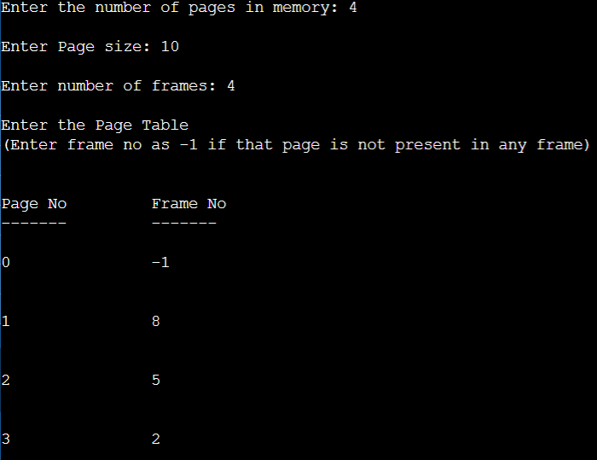

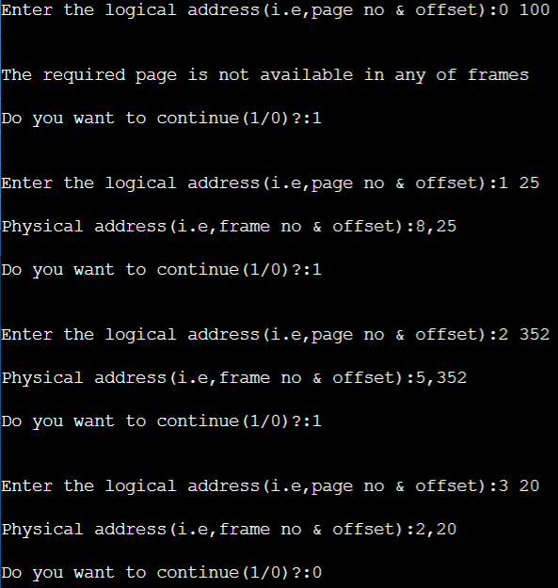

**Observation Book Pictures:**

